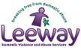
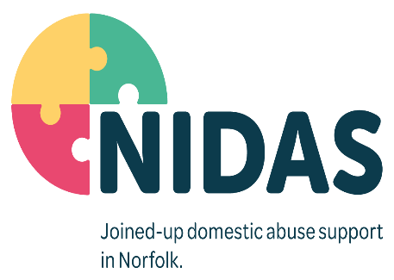
Job Description
Job Title | Community Development and Group Recovery Facilitator
Responsible for | Volunteer Facilitators
Direct Reports to | NIDAS Assistant Manager
Job Purpose
You will be part of our team delivering Norfolk Domestic Abuse Services (NIDAS), which is a community-based service providing effective, safe, supportive, and confidential support for service users aged 16 plus who are assessed as high or medium risk and are living with or fleeing domestic abuse.

To enhance the community response to domestic abuse in Norfolk by supporting a network of Domestic Abuse Champions working within services and organisations most likely to have contact with people who are or have been experiencing domestic abuse.

To support early intervention before risk increases by building the skills, knowledge, and capacity of others to identify victims of domestic abuse and respond appropriately.

To co-ordinate and deliver group programmes to provide support for the long-term recovery for survivors of domestic abuse and their children, to prevent re-victimisation and enable survivors to be better able to recover and cope with aspects of everyday life.

Key Strategic Responsibilities
- To develop the awareness, confidence, and skills of front-line staff to reduce risk and increase safety for victims of domestic abuse who may not already be engaged with services.
- To ensure the service recognises the needs and concerns of a diverse range of people and addresses them appropriately by working proactively to ensure that a non- discriminatory service is accessible to all eligible service users and external attendees by providing delivery in a range of formats, platforms, locations, and times.
- To communicate positively with colleagues and promote NIDAS values and ethos across the organisation.
- To promote the work of NIDAS modelling a high standard of professional behaviours
Key Functional Responsibilities
- To recruit, coordinate and maintain a network of DA Champions within a variety of front-line organisations to deliver a consistent approach to identifying and supporting victims of domestic abuse, ensuring effective coordination with other services.
- Co-ordinate external training delivery to meet national, local and partner initiatives and develop community capacity that supports wider vulnerability, well-being, economic and family objectives.
- To facilitate delivery of group programmes across Norfolk by face to face and digital platforms to support the recovery of survivors of domestic abuse and their children and enable them to form support networks and move on with increased confidence and well-being.
- To train and support others to deliver awareness sessions, group programmes and Domestic Abuse Champions training to create a network of recovery facilitators and skills enhancers across Norfolk.
- To undertake regular audits of service user recovery programme needs, external training requirements and distribution of trained domestic abuse champions to identify and develop training and facilitation plans to provide consistent provision that flexibly meets strategic and priority needs.
- Use outcome and evaluation data to review internal and external delivery to ensure that the programmes and training delivered is effective, high quality and meets client and partner need, achieving accreditation for courses that do not currently have this.
- To attend and participate positively in relevant meetings, training, supervision, and appraisals.
- To liaise with and train external agencies to increase public awareness of the issues surrounding domestic abuse.
- To represent NIDAS at appropriate meetings and forums.
- To develop positive links with voluntary and statutory agencies.
- To keep up to date with national and local government decisions pertinent to the role.
- To maintain appropriate records relating to training, DA Champions network, events and other activities.
- To keep clear records relating to safeguarding concerns.
- To undertake all other reasonable tasks requested by the management team.

Person Specification
Education & Qualifications | - Idva qualification, or other relevant accreditation would be desirable, or a minimum of two years’ experience of working with victims of domestic abuse.
Experience | - Experience of working in a voluntary or statutory agency for a minimum of two years with victims of domestic abuse  - Experience and a proven track record of partnership working and have the skills and ability to build and maintain positive relationships with partners and stakeholders.
Knowledge & Skills | - Knowledge of legislation, around safeguarding vulnerable adults and children  - Excellent written and verbal communication skills, engaging with both customers, colleagues, and partners.  - To be confident at presenting information in a variety of situations, including formal training, face to face and remotely and dealing with feedback and challenges  - Ability to create an inclusive supportive learning environment that is responsive to the needs of different attendees.  - IT skills including use of Microsoft Office, Word, PowerPoint, and Excel.  - Inquisitive and problem solving. A commitment to seeking new ways of working to achieve positive outcomes.  - A clear understanding of Data Protection, confidentiality, and data sharing protocols.  - An understanding of a strengths-based and trauma informed approach to support.  - Must have knowledge of Signs of Safety, Family Support Processes, Safeguarding Children and Vulnerable Adult procedures, Domestic Abuse Risk Assessing, Safety Planning and support agencies.
Values | - Reliable, enthusiastic, non-judgmental, and understanding.  - Ability to be flexible and work independently, or as part of a team.  - Ability to respond calmly in sometimes pressured situations.  - Respect and value the diversity of the community and recognise the needs and concerns of a diverse range of survivors ensuring the service and your approach is accessible to all.  - Always seek to expand your learning and undertake all training and development essential for this role.
Other | - Full valid driving licence and use of own transport

