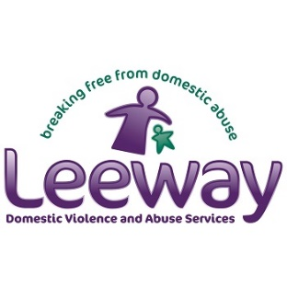
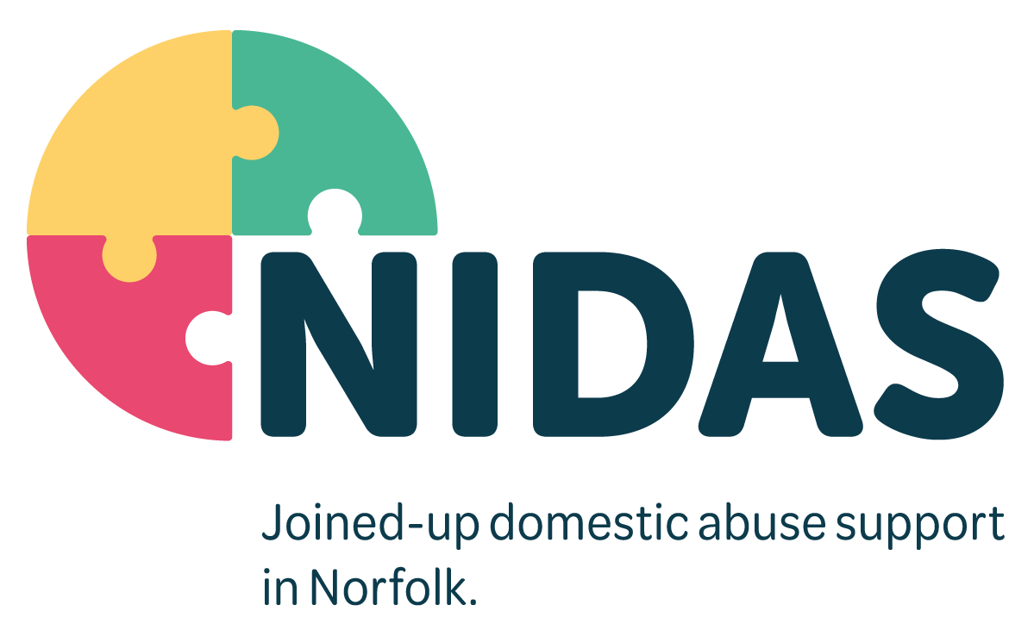

NIDAS Job Description

Job Title | CAPVA Triage Independent Domestic Abuse Advisor (IDVA)
Direct Reports | NIDAS Triage Senior Independent Domestic Abuse Advisor
Based | Norwich (Multi Agency Safeguarding Hub) MASH
Job Purpose
The CAPVA Triage IDVA will be part of our team within the Norfolk Integrated Domestic Abuse Service (NIDAS), a community-based service providing effective, safe, supportive, and confidential support for service users aged 16 plus and their families including children aged 5-18, who are assessed as high or medium risk, and living with or fleeing domestic abuse.

The purpose of the role is to work in a multi-agency environment providing an assessment of risk and offering CAPVA support to reduce the risk of further harm posed to service users and their families.

The support will be provided depending on the needs of the caller/referral through the phone or email, you will provide referrals to the NIDAS CAPVA service identified by the Police.

To triage all CAPVA referrals and input all data onto an approved database in-line with reporting requirement and under the direction of the Senior IDVA.

Your support will ensure service users feel safe, happy with the service they are receiving and have the widest opportunities available to them to enhance their lives and improve their safety and wellbeing, using a strengths-based, trauma informed approach that is centred around their aims and aspirations.

This role is subject to DBS and enhanced Police security clearance.

Key Strategic Responsibilities
- Work in a multi-agency environment, safeguarding adults and children.
- Promote Equality, Diversity, Fairness, and Inclusion at all times.
- Promote a ‘Team NIDAS’ culture across the service delivery.
- Ensure that our service users voices are central to all aspects of service delivery and is evidenced through safety and support planning, risk assessment and reviews.
- Be part of a team of community and family IDVAs and work collaboratively with colleagues throughout the NIDAS Partnership to deliver our visions, values, and objectives.
- Be innovative in identifying methods to successfully engage with people across a wide range of backgrounds and with diverse needs.
- Look for opportunities to improve and develop services that we offer.
- To promote collaboration and multi-agency working for service users and maintain up to date knowledge of local services to enable recovery.
- Support our service users to link into statutory, health and social care services to maximise their wellbeing and recovery.
- To implement NIDAS’s strategy on consultation and service user involvement to ensure that all service users are able to participate and contribute to the development of the NIDAS service.

Key Functional Responsibilities
- Build a relationship with each service user and engage at their pace and in their preferred way; taking a service user led, flexible approach to providing practical and emotional support and advocacy.
- To assess all CAPVA referrals using an approved CAPVA risk assessment toolkit to address immediate support and safety needs in line with the accredited standards.
- Comply with all Health & Safety policy and procedures and carry out activities in a safe manner.
- Maintain accurate and thorough case records.
- Comply within Data Protection and GDRP legislation and best practice.
- To offer telephone and virtual advice and support to service users who have been referred to the NIDAS CAPVA service.
- To liaise with other teams within the NIDAS partnership to ensure seamless handover of service between the triage service and other teams within NIDAS.
- To ensure that all Safeguarding issues and concerns are reported and dealt with in accordance with organisational policy and procedure, Legislation, and best practice.
- To promote and work within the policies and guidelines of NIDAS and employing organisations.

Person Specification
Education & Qualifications | - An accredited IDVA qualification or working towards one.  - Driving Licence, Business insurance and ability to travel around Norfolk
Experience | - Experience of working in a voluntary or statutory agency for a minimum of two years with victims of domestic abuse.  - Experience of using risk assessment tools for victims of domestic abuse.
Knowledge & Skills | - Knowledge of legislation around safeguarding vulnerable adults and children.  - Excellent written and verbal communication skills, engaging with service users, colleagues, and partners.  - IT skills including use of Microsoft Office, Teams, case management systems, and databases.  - Inquisitive and problem solving. A commitment to seeking new ways of working to achieve positive outcomes.  - A clear understanding of Data Protection, confidentiality, and data sharing protocols.  - An understanding of a strengths-based and trauma informed approach to support.  - An understanding of the impact of domestic abuse on young people, children, and families.
Values | - Reliable, enthusiastic, non-judgmental, and understanding.  - Ability to be flexible and work independently, or as part of a team  - Ability to respond calmly in sometimes pressured situations.  - Respect and value the diversity of the community and recognise the needs and concerns of a diverse range of survivors ensuring the service and your approach is accessible to all.  - Always seek to expand your learning and undertake all training and development essential for this role.

