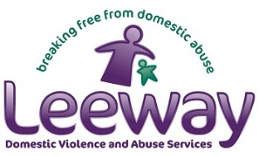
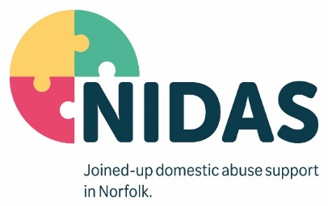
Job Description

Job Title | Family IDVA
Responsible for | Volunteers, Students
Direct Reports | NIDAS Senior Independent Domestic Abuse Advisor
Based | To be confirmed on role
Job Purpose

The Family IDVA will be part of our team within the Norfolk Integrated Domestic Abuse Service (NIDAS), which is a community-based service providing flexible, safe, supportive, and confidential service through face to face or accredited groupwork for children and young people who have experienced or are living domestic abuse.

The purpose of the Family IDVA role is to work in a multi-agency environment in partnership with the IDVA supporting the non-abusive parent. You will also provide holistic whole family support to encourage and empower children and young people to take control of their lives and assist them in making choices appropriate to their age and development level. You will need to be creative, plan and run a range of therapeutic activities for children and young people.

Full and accredited training to work with children and young people (aged 5-18) will be provided to give the skills and knowledge for the role, following a successful probation period. This training will result in a nationally recognised qualification.

You will be required to represent the service by providing presentations and attending events as required and support the NIDAS Partnership Board in working towards the best possible outcomes for our service users.

This role is subject to DBS and enhanced Police security clearance.

Key Functional Responsibilities

- Build a relationship with each service user and engage at their pace and in their preferred way; taking a service user led, flexible approach to providing practical and emotional support and advocacy.
- To offer telephone, face-to-face and group advice and support to children and young people who have experienced domestic abuse and make referrals to other agencies as appropriate.
- To work with children and young people between the ages of 5 – 18 years old, to develop support plans, risk assessments and safety planning appropriate to the age and emotional development level of each child and young person. Regularly review support and safety needs in line with the accredited standards.
- To create opportunities using play, games, sports, drama, and artwork in order to stimulate young people’s intellectual, social, and emotional development.
- Facilitate a holistic assessment with children and young people, building a relationship and creating a personalised support plan that incorporates risk and safety, and builds on their strengths and needs.
- Comply with all Health & Safety policy and procedures and carry out activities in a safe manner.
- Maintain accurate and thorough case records.
- Comply within Data Protection and GDRP legislation and best practice.
- To participate in multi-agency meetings and service user groups as appropriate.
- To work in partnership with education and youth services promoting the service, meeting the needs of children and young people, and identifying pathways available to meet their needs.
- To ensure that all safeguarding issues and concerns are reported and dealt with in accordance with organisational policy and procedure, legislation, and best practice.
- To promote and work within the policies and guidelines of NIDAS and employing organisations.

Key Strategic Responsibilities

- Work in a multi-agency framework and environment, safeguarding adults and children.
- Promote Equality, Diversity, Fairness, and Inclusion at all times.
- Promote a ‘Team NIDAS’ culture across the service delivery.
- Ensure that our service users voices are central to all aspects of service delivery and is evidenced through safety and support planning, risk assessment and reviews.
- Be part of a team of community and family IDVAs and work collaboratively with colleagues throughout the NIDAS Partnership to deliver our visions, values and objectives.
- Be innovative in identifying methods to successfully engage with people across a wide range of backgrounds and with diverse needs.
- Look for opportunities to improve and develop services that we offer.
- To promote collaboration and multi-agency working for service users and maintain up to date knowledge of local services to enable recovery.
- Support our service users to link into statutory, health and social care services to maximise their wellbeing and recovery.
- To implement NIDAS’s strategy on consultation and service user involvement to ensure that all service users can participate and contribute to the development of the NIDAS service.

Person Specification

Education & Qualifications | Essential  - Driving Licence, Business insurance and ability to travel across Norfolk.  Desirable  - A relevant childcare qualification level 3 or equivalent and experience of working with children and young people.
Experience | Essential  - Experience of working in a voluntary or statutory agency for a minimum of two years with children and young people or vulnerable people.  - Experience of advocating for children and young people.  Desirable  - Experience of using risk assessment tools for victims of domestic abuse.  - Experience of being creative, planning and running a range of therapeutic activities for children and young people.  - Experience of delivering talks and presentations to children, young people and agencies.
Knowledge & Skills | Essential  - Knowledge of legislation around safeguarding vulnerable adults and children.  - Excellent written and verbal communication skills, engaging with service users, colleagues, and partners.  - IT skills including use of Microsoft Office, Teams, case management systems, and databases.  - Inquisitive and problem solving. A commitment to seeking new ways of working to achieve positive outcomes.  - A clear understanding of Data Protection, GDPR, confidentiality, and data sharing protocols.  Desirable  - An understanding of a strengths-based and trauma informed approach to support.  - An understanding of the impact of domestic abuse on young people, children, and families.
Values | - Reliable, enthusiastic, non-judgmental, and understanding.  - Ability to be flexible and work independently, or as part of a team.  - Ability to respond calmly in sometimes pressured situations.  - Respect and value the diversity of the community and recognise the needs and concerns of a diverse range of children and young people ensuring the service and your approach is accessible to all.  - Always seek to expand your learning and undertake all training and development essential for this role.

